**Assignment 1**

**Batch 87 Name : Nilesh Gorule**

**Operators**

**Arithmetic Operators:**

**1. What is the result of 5 + 3?**

a = 5

b = 3

res = a+b

print("addition of two no is :", res);

**addition of two no is : 8**

**2. Evaluate the expression 10 - 4.**

a = 10

b = 4

res = a-b

print("substraction of two no is :", res);

**substraction of two no is : 6**

**3. Calculate the value of 6 * 7.**

a = 6

b = 7

res = a*b

print("multiplication of two no is :", res);

**multiplication of two no is : 42**

**4. Compute the result of 15 / 3.**

a = 15

b = 3

print("result is ",int(a/b))

**result is 5**

**5. What is the output of 10 // 3?**

a = 10

b = 3

print("result is ",int(a//b))

**result is 3**

**6. Calculate the remainder of 12 % 5.**

a = 12

b = 5

print("result is ",a%b)

**result is 2**

**7. Evaluate 2 ** 4 (2 raised to the power of 4).**

a = 2

b = 4

print("result is ",a**b)

**result is 16**

**8. Given x = 5 and y = 3, what is the value of x + y * 2?**

x = 5

y = 3

print("result is ",x+y*2)

**result is 11**

**Comparison Operators:**

9. Evaluate the expression: 7 > 5.

a = 7

b = 5

print(a>b)

True

m

10. Is the statement 10 < 5 true or false?

print(10>5)

False

11. Determine the result of 8 >= 8.

print(8>=8)

True

12. Check if 6 == 6.

print(6==6)

True

13. Is the statement 3 != 3 true or false?

print(3!=3)

False

14. Given x = 10 and y = 5, is x > y or x < y?

x = 10

y = 5

print(x>y , x<y)

True False

15. Determine the output of "hello" == "Hello".

print("hello" == "Hello")

False

**Logical Operators:**

16. What is the result of True and False?

print(True and False)

False

17. Evaluate the expression: True or False.

print(True or False)

18. Determine the value of not True.

print(not True)

false

19. Is 10 > 5 and 5 < 2 true or false?

print(10>5 and 5<2)

print(10>5 or 5<2)

False

True

20. Check if (3 == 3) or (4 != 4).

print(3==3 or 4!=4)

True

**Assignment Operators:**

21. Assign the value 10 to a variable 'x'.

22. Increment the variable 'x' by 3.

23. Subtract 5 from the variable 'x'.

24. Multiply the variable 'x' by 2.

25. Divide the variable 'x' by 4.

26. Calculate the modulus of 'x' with 3.

27. Perform an exponentiation operation on 'x' with 2.

x = 10

print(x)

x += 3    #increment by 3

print(x)

x -= 5    # substract by 5

print(x)

x *= 2    #multiply by 2

print(x)

x /= 4    #divide by 4

print(x)

x %= 3    #calculate modulus by 3

print (x)

x **= 2   # exponentiation operation x with 2

print(x)

**output:**

**10**

**13**

**8**

**16**

**4.0**

**1.0**

**1.0**

**Performing output in integer values**

x = 10

print(x)

x += 3    #increment by 3

print(x)

x -= 5    # substract by 5

print(x)

x *= 2    #multiply by 2

print(x)

x /= 4    #divide by 4

print(int(x))

x %= 3    #calculate modulus by 3

print(int(x))

x **= 2   # exponentiation operation x with 2

print(int(x))

**output:**

**10**

**13**

**8**

**16**

**4**

**1**

**1**

**Membership Operators:**

34. Check if the element 3 is present in the list [1, 2, 3, 4, 5].

35. Determine if the character 'a' exists in the string "hello".

36. Check if the key 'age' is present in the dictionary {'name': 'John', 'age': 30}.

#34. Check if the element 3 is present in the list [1, 2, 3, 4, 5].

a = [1,2,3,4,5]

result = 3 in a

print(result)

#35. Determine if the character 'a' exists in the string "hello".

a = "hello"

result = "a" in a

print(result)

#36. Check if the key 'age' is present in the dictionary {'name': 'John', 'age': 30}.

a = {'name': 'John', 'age': 30}

result = "age" in a

print(result)

output

True

False

True

**Precedence and Associativity:**

39. Evaluate the expression: 5 + 3 * 2.

40. Calculate the value of (10 + 3) * 2.

41. What is the result of 10 + 3 / 2?

42. Determine the output of 8 - 4 + 2.

#39. Evaluate the expression: 5 + 3 * 2.

print(5 + 3 * 2)

 #Associativity (Left to Right)

#40. Calculate the value of (10 + 3) * 2.

print((10 + 3) * 2)

#Associativity (Left To Right)

#41. What is the result of 10 + 3 / 2?

print(int(10 + 3 / 2))

#Associativity (Left To Right)

#42. Determine the output of 8 - 4 + 2.

print(8 - 4 + 2)

#Associativity (Left To Right)

m

|  |  |  |  |
| --- | --- | --- | --- |
| **Precedence** | **Operator** | **Description** | **Associativity** |
| **1** | **+,\*** | **Addition, subtraction** | **Left to Right** |
| **2** | **(),+,\*** | **Parentheses, addition**  **Subtraction** | **Left to Right** |
| **3** | **+,/** | **Addition , Division** | **Left to Right** |
| **4m** | **-,+** | **Subtraction ,Addition** | **Left to Right** |

**Chaining Operators:**

43. Check if 10 is between 5 and 15.

44. Determine if a number is positive and even.

45. Check if a character is a lowercase letter and not a vowel.

#Chaining Operators:

#43. Check if 10 is between 5 and 15.

x = 10

print(5<x<15)

#44m. Determine if a number is positive and even.

a = int(input("Enter a Number:"))

if a > 0:

    if(a % 2 == 0):

print("Number is positive and even")  
else:

   print("number is nagtive")

45. Check if a character is a lowercase letter and not a vowel.

def vowel(c):

    return c.lower() in ['a','e','i','o','u']

c = input("Enter a Character:")

if vowel(c):

    print("Lowercase and Vowel")

else:

    print("Lowercase not a vowel" )

**output:**

**#43 True**

**#44 and #45**

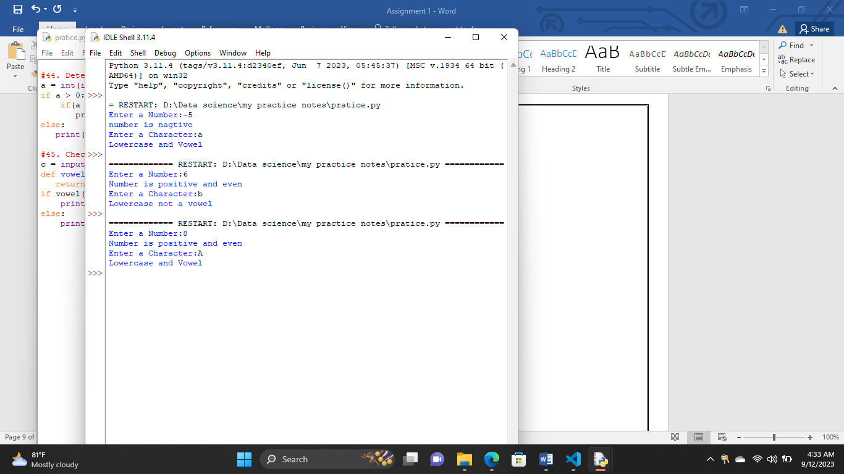

**Ternary Operator:**

47. Use the ternary operator to assign the value 10 to 'x' if 'y' is True, otherwise assign 5.

y = True

x = 10 if y else 5

print(x)

y = False

x = 10 if y else 5

print(x)

output:

10

5

**Operator Precedence:**

48. Discuss the precedence of arithmetic, comparison, and logical operators.

Arithmetic – 1

Comparison -2

Logical – 3

#Arithmetic

print(1+6==6)

#Comparison

print(1+5==5<8)

#logical

print(10+2 and 10<2)

print(10+2 or 10<2)

output:

False

False

False

12

**Operator Overloading:**

49. Explain the concept of operator overloading in Python with an example.

def num(a,b):

p = (a + b)

print(p)

def num(a,b,c):

p = (a * b + c)

print(p)

num(4,5,2)

output:

22

**Combining Operators and Control Flow:**

50. Write a Python program that takes two numbers as input and prints their sum if both numbers are positive, otherwise prints "Invalid input."

num1 =int(input("Enter first no:"))

num2 =int(input("Enter second no:"))

if num1>0 and num2>0:

ans = num1 + num2

print(ans)

else:

print("invalid input")

